Course Assignment Report  
03.21.2022 – 03.27.2022  
Patrick Nordbo Johnsen

Font uses: Montserrat, sans-serif

# Introduction

When reading the assignment, I installed Hotjar right away and created a feedback button with Hotjar  
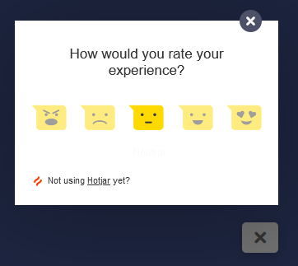  
While waiting for feedback I worked on cleaning up the CSS and HTML before working on the JavaScript.  
When I received the feedback I started removing/adding new content for the page making it more user friendly and having a good user experience when navigating through the website.

# Main

After going through the feedback, I went to the Course Assignment for HTML and CSS to look at the feedback from the tutor and corrected the errors that we’re pointed out.

I was going through the old code and cleaned up multiple lines of CSS and HTML code that was unnecessary, there we’re a lot of old images as well that we’re unused that is now removed, I’ve also reduced the file size for some images, mainly the logo, I did this to reduce the loading time.  
  
When looking at the old design I wanted to recreate the list of games page, I ended up removing all work done on that page and made a JavaScript file that fetches files from a gaming database with a lot of games. The website is rawg.io, which was shown in a JavaScript lesson.  
I’ve also removed cart, checkout and checkout success and recreated them with API calls.  
I used query strings to paste in the unique ID of each game to make this possible.

I’ve decided to leave a changelog here so it’s easier to see what has been changed.  
Website Changelog

* -Categories section in index.html is removed.
* -Removed game.html page, as it has been replaced with the api game page
* -All console.log are removed except for error catch console log
* -Removed sign up and list game option on index.html
* - Added API to the List.html page to gather games with API
* - Remade game.html page to display the specific game with a purchase button which leads to the checkout page and then checkout success page

I did a lot of research looking at other gaming stores such as Steam and Epic Games.  
And both have a lot of positives and negatives

Steam has a lot of positives when it comes to user experience, it’s easy to navigate and you know where you are at all time. But it looks very outdated, which might turn people away from the website due to its appearance.

Epic games store does kind of the opposite, it has a very modern UI but lacks quite a lot when it comes to UX, you easily get lost and can be quite the pain to actually find the games you own, the store page does not include a review page which is quite unfortunate.

My attempt at GameHub was to combine both positives of these webpages, which was to make it modern like epic games store and UX friendly like steam and I feel like I accomplished that goal.

# Conclusion

This CA was a lot of fun to do, it shows very well how much I’ve improved in 1 year.  
Seeing my old gamehub page was also a nice way to reflect on my time learning and seeing how much I’ve improved at design, understanding the customer and writing websites.